**Applied Data Science Capstone**

**Capstone Project - Week 4 Only**

**Index**

1. **Introduction**

1. **Data acquisition and cleaning**

.

1. **Introduction:**

The technology industry is growing on a faster pace than ever. New world industries are changing the face of our cities in terms of job types, education, entertainment and culture. I have tried to analyze growing cities of The United States of America on the terms of popular venues like food, restaurants, entertainment and cultural activities. For this project I have chosen 4 fast growing cities of four different parts of the USA. Following are the cities and their respective populations-

City Population

Columbus, OH - 892,533

Boston, MA - 694,583

Charlotte, NC - 872,498

Austin, TX - 964,254

Data Source: <https://en.wikipedia.org/wiki/List_of_United_States_cities_by_population>

This data science project is an attempt to analyze these four cities and tries to understand what popular venues in them are and what they have to offer to someone who is contemplating to make a choice on seeking a life in any of these cities.

1. **Data acquisition and cleaning:**

I have used Foursquare API in order to get the popular venues of these four cities. The code snippets for the data collection and cleaning are the following:

**Columbus:**

1. Getting Columbus longitude and latitude:

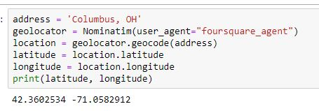

1. Columbus cleaned dataframe

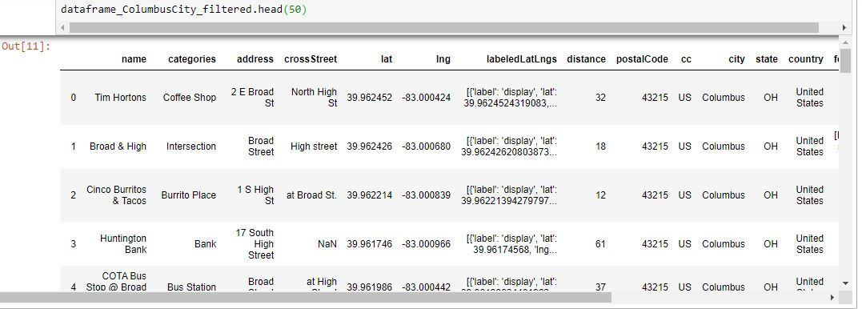

1. Venue categories of Columbus:

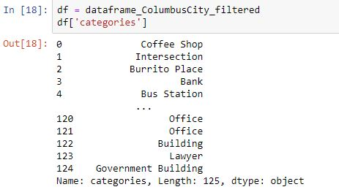

1. Columbus venues map

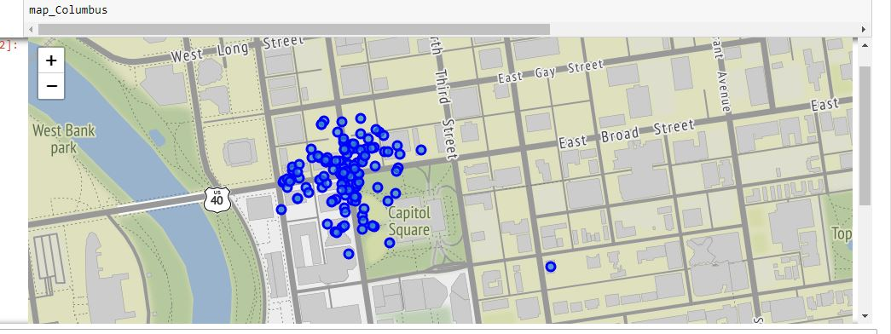

**Boston, MA:**

1. Getting Boston longitude and latitude:

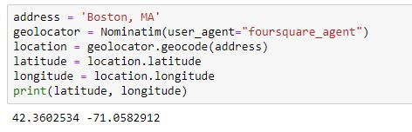

1. Boston cleaned dataframe

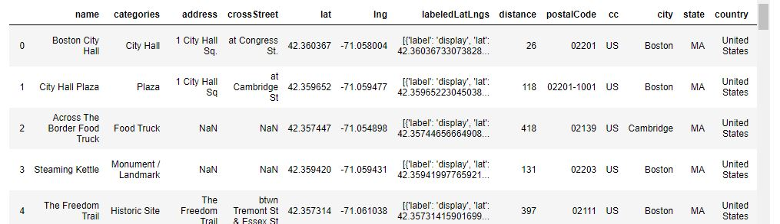

1. Venue categories of Boston

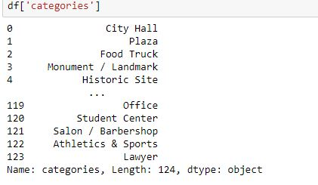

1. Boston venues map

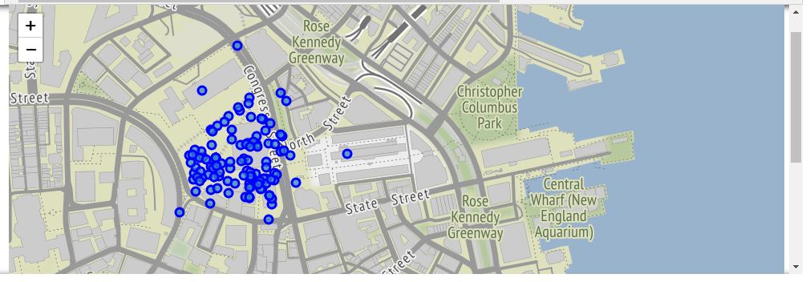

**Austin, TX:-**

1. Getting Austin longitude and latitude:

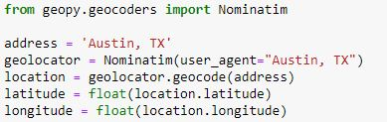

1. Austin cleaned dataframe

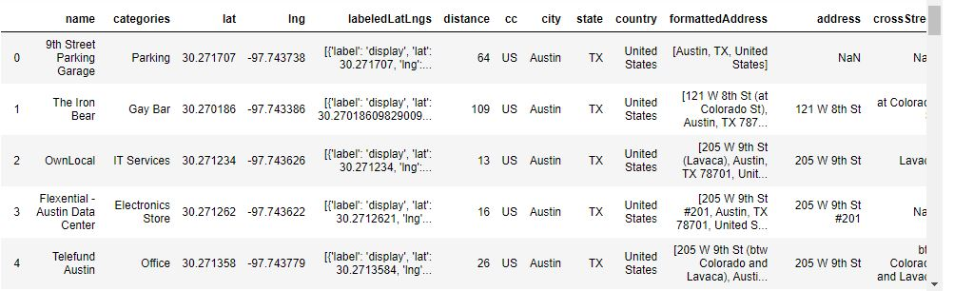

1. Venue categories of Austin

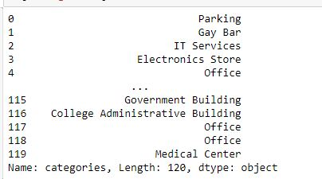

1. Austin venues map

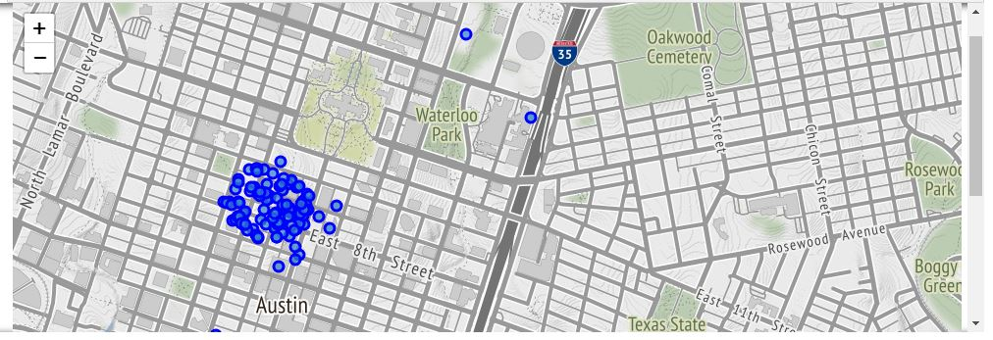

**Charlotte, NC:**

1. Getting Charlotte longitude and latitude:

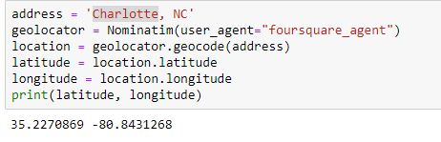

1. Charlotte cleaned dataframe

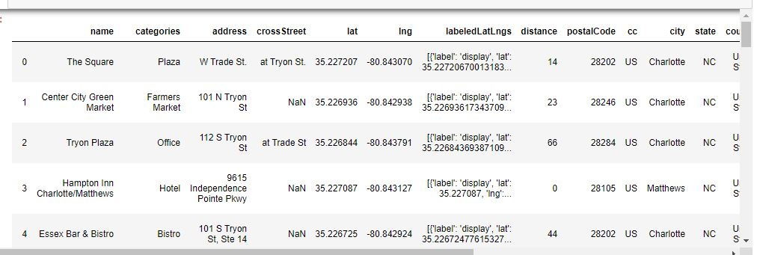

1. Venue categories of Charlotte

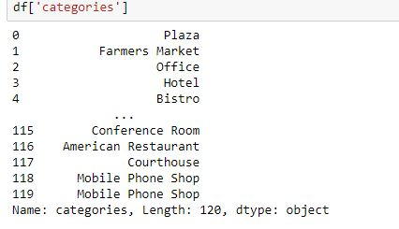

1. Charlotte venues map

